Leatherstockings & More

A Presentation on 19th-Century Tanneries

By Tom Washbon

Wednesday, October 18 at 7 pm
Morris Fire House, 117 Main St.

You may also join a Zoom Meeting found at www.butternutvalleyalliance.org or using this QR code

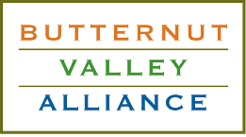
Sponsored by the BVA
(facebook at Butternut Valley Alliance)
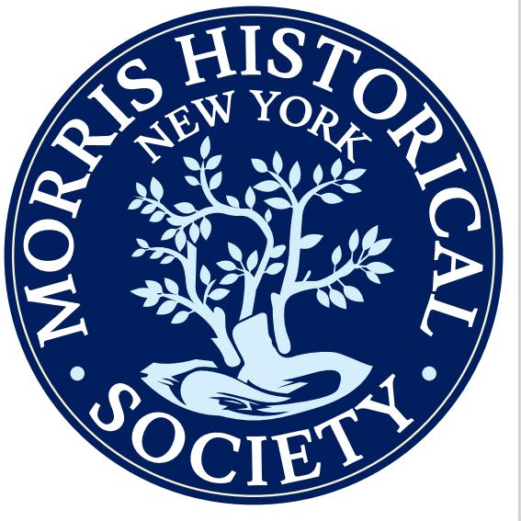
and
the Morris Historical Society
(facebook at Morris, NY Historically Speaking)

